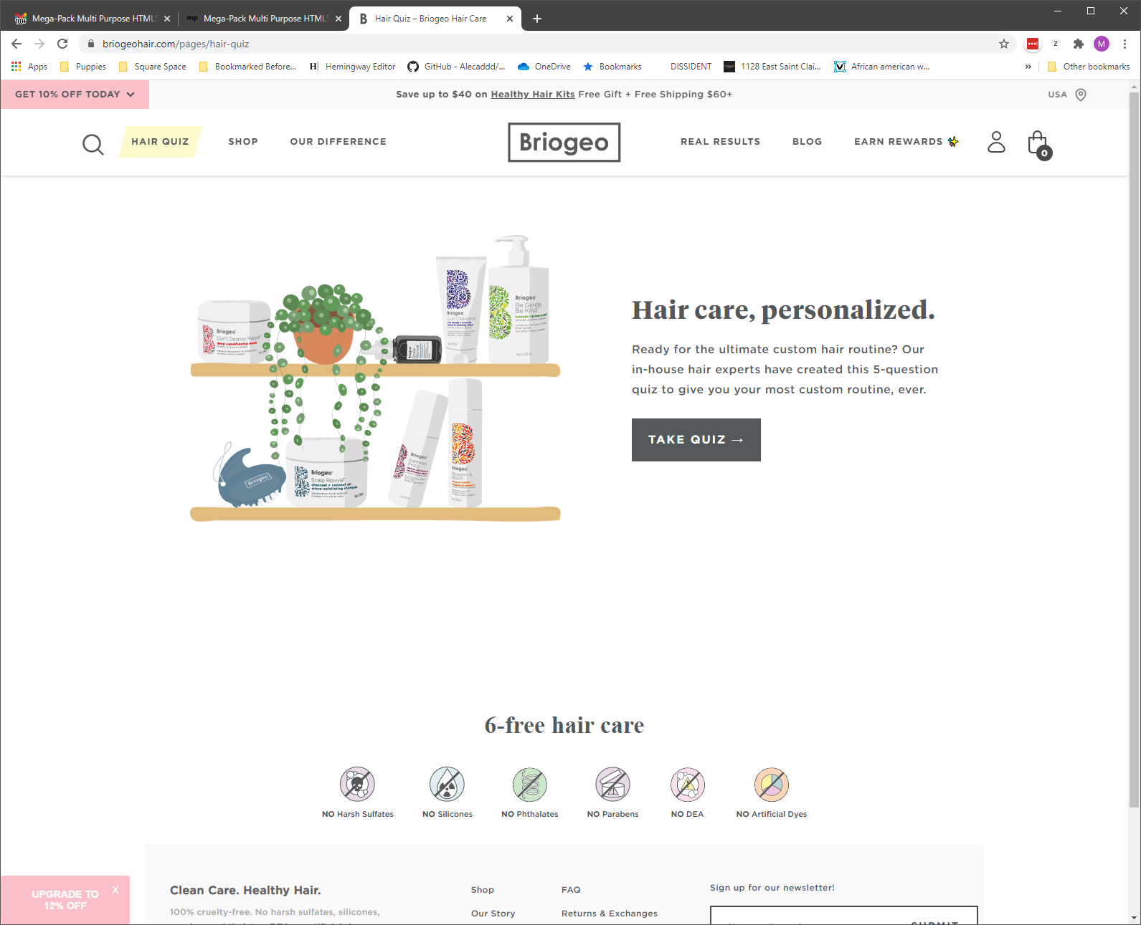

<https://websitedemos.net/organic-shop-08/>

<https://briogeohair.com/pages/ingredients>

https://websitedemos.net/cosmetics-store-08/

https://websitedemos.net/ayurveda-04/

+

s

w

ds

e

s

d

e

d

4

4x

d4

d

s

e

d

e

fr

f

g

z

z

f

c

j

v

f

v

v

v

t

v

g

f

d

d

d

d

s

s

s

s

x

x

